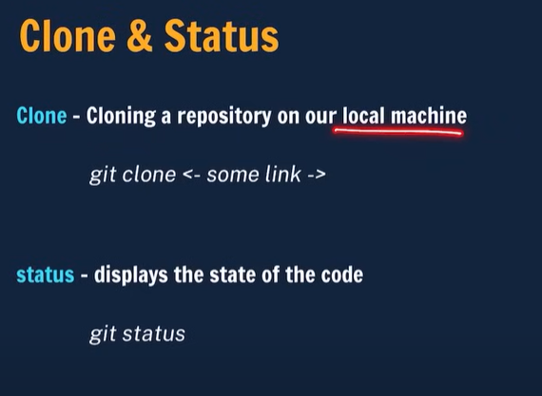

To copy a GITHUB repo on our local machine we use clone

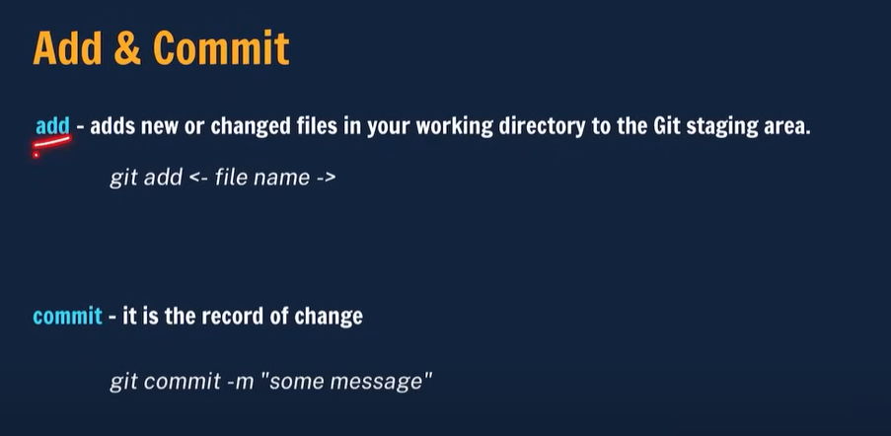

When we modifie a existing file or add a new file in a project that time we need to add the files to git after adding we need to commit the changes with the message.

When we want to send local changes to github me neew git push

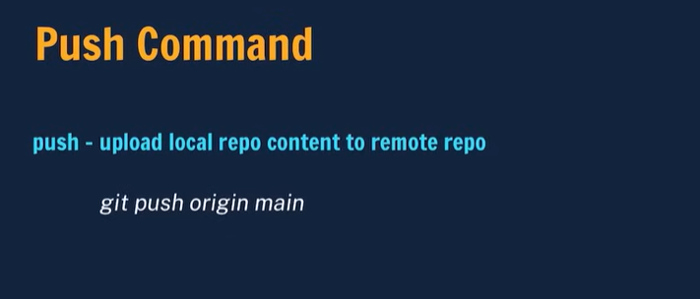

How to make local repository our git repository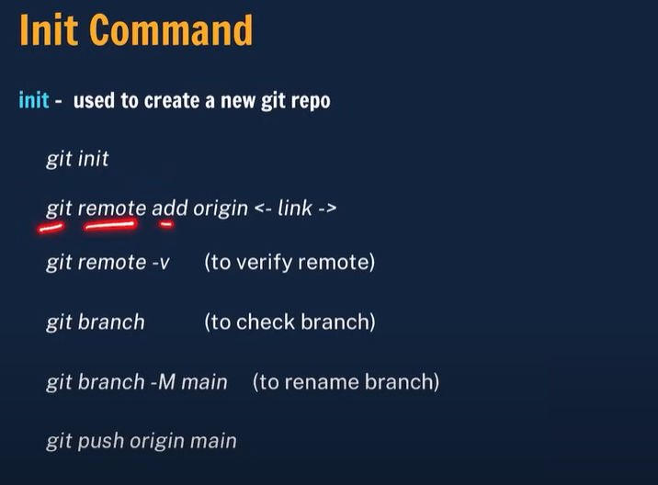

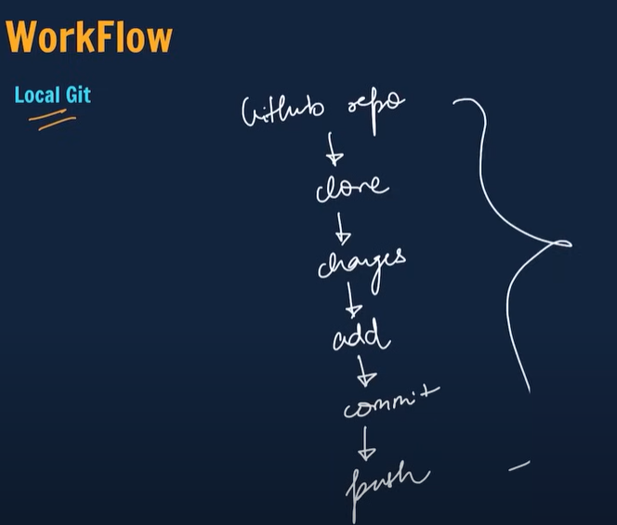

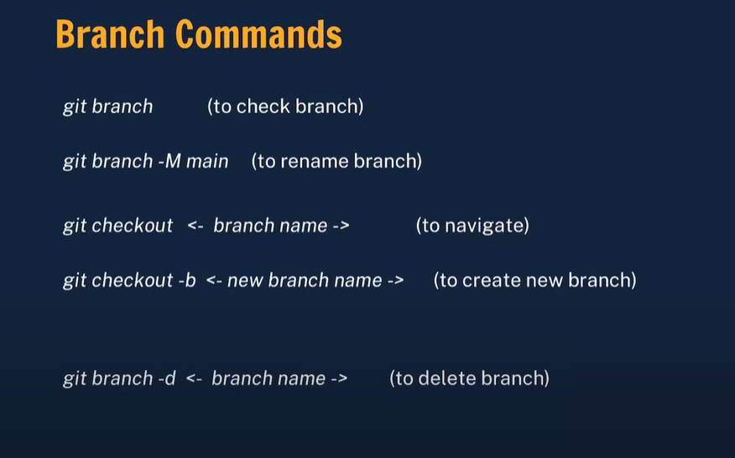

Branches allow you to work on different parts of a project without impacting the main branch.

When the work is complete, a branch can be merged with the main project.

You can even switch between branches and work on different projects without them interfering with each other.

Branching in Git is very lightweight and fast!

